**Technical Memorandum 4.4: University Parking Lot Choice Model Development and OSU Model Calibration**

|  |  |
| --- | --- |
| **Prepared for:**  LCOG University Model Development Team |  |
| **Prepared by:**  Parsons Brinckerhoff  400 SW 6th Ave, Suite 802 Portland, Oregon 97204 | **PB Logo RGB.jpg** |

**March 2014 (Working Version)**

Table of Contents

Introduction 3

Parking Lot Data Processing 3

Parking Lot Selection Data 3

Parking Capacity 3

Model Parking Lots 4

Model Formulation 6

Parking Lot Choice Specification 6

Shadow Price Calculation 6

Tour Mode Choice Specification Changes 7

Model Calibration 8

Student Residential Location Choice Model 8

Worker Location Choice Model 9

Auto Ownership Model 10

Parking Lot Choice 11

Parking Lot Choice Model Results 11

Parking Lot Choice Model Calibration 22

Tour Mode Choice 26

Trip Mode Choice 28

Parking Lot Choice Model User’s Guide 32

Input Files 32

New Output Files 32

Table of Tables

Table 1: Calibration Constants for Student Residential Location Choice 8

Table 2: Worker Location Choice Calibration Constants 9

Table 3: Auto Ownership Calibration Targets and Constants 10

Table 4: Faculty/Staff Parking Lot Choice Results 22

Table 5: Student Parking Lot Choice Results 24

Table 6: Student Tour Mode Choice Calibration Targets 26

Table 7: Faculty/Staff Tour Mode Choice Calibration Targets 26

Table 8: Student Tour Mode Choice Calibration Constants 27

Table 9: Faculty/Staff Tour Mode Choice Calibration Constants 27

Table 10: Absolute Difference in Student Tour Mode Shares 27

Table 11: Absolute Difference in Faculty/Staff Tour Mode Shares 28

Table 12: Student University Tour Trip Mode Choice Calibration Targets 28

Table 13: Student Non-University Tour Trip Mode Choice Calibration Targets 29

Table 14: Faculty/Staff Work Tour Trip Mode Choice Calibration Targets 29

Table 15: Student University Tour Trip Mode Choice Calibration Constants 29

Table 16: Student Non-University Tour Trip Mode Choice Calibration Constants 30

Table 17: Faculty/Staff Work Tour Trip Mode Choice Calibration Constants 30

Table 18: Student University Tour Absolute Difference in Trip Mode Shares 30

Table 19: Student Non-University Tour Absolute Difference in Trip Mode Shares 30

Table 20: Faculty/Staff Work Tour Absolute Difference in Trip Mode Shares 31

Table 21: New UEC and Probability Distribution Files 32

Table of Figures

Figure 1: Map of Parking Lot Locations by Type 6

Figure 2: Student Residential Location Choice Model Distance Frequency Distribution 10

Figure 3: Faculty/Staff Residential Location Distance Frequency Distribution 11

Figure 4: Auto Ownership Calibration Results 12

Figure 5: Faculty/Staff Parking Utilization at 7:00 13

Figure 6: Faculty/Staff Parking Utilization at 8:30 14

Figure 7: Faculty/Staff Parking Utilization at 10:30 15

Figure 8: Faculty/Staff Parking Utilization at 12:30 16

Figure 9: Student Parking Utilization at 8:00 17

Figure 10: Student Parking Utilization at 9:30 18

Figure 11: Student Parking Utilization at 10:30 19

Figure 12: Student Parking Utilization at 11:30 20

Figure 13: Student Parking Utilization 12:30 21

Figure 14: Parking Time of Day Distribution for Zone 210 22

Figure 15: Parking Time of Day Distribution for Zone 371 23

# Introduction

This memorandum describes the development of a parking lot location choice model component of the Major University Travel Model developed for the Oregon Department of Transportation. The University Travel Model was originally developed for the University of Oregon, and subsequently extended to forecast student and faculty/staff travel at Oregon State University (OSU). Parking on the OSU campus is limited for both students and faculty/staff, and many of the parking lots are already near capacity. The purpose of this work was to develop a tool to forecast parking lot usage on campus based on the available parking capacity data and the parking choice information provided in the Oregon State University travel survey. The final model includes a time-dependent parking lot choice component which ensures that vehicle demand does not exceed available capacity at each lot.

# Parking Lot Data Processing

Data used to develop the parking location choice model came from three sources: the Oregon State University Travel Survey, the Parking Utilization Study, and estimates of off-campus residential roadway miles.

## Parking Lot Selection Data

Analysis of the data from the OSU student travel survey showed that the selection of the parking lot was based not only on the distance from the lot to the on-campus destination but also on the amount and type of parking available. The data showed that only 14% of students chose the lot closest to their on-campus destination. The remaining 86% of students parking chose to park in lots that were further away but larger for the most part. Based on the fact that the closest lot was not always the one selected, the parking lot model was formulated with multiple variables, including the total lot capacity, in order to draw students to the larger lots as was seen in the survey data.

## Parking Capacity

The parking model was formulated to use the parking capacity in two ways: 1) as a size term to attract students and faculty/staff to larger parking lots and 2) to penalize lots in which the number of parked cars at the lot is close to or at capacity. The penalties were used to ensure the correct distribution of vehicles across lots and will be discussed in more detail in the model formulation section.

### On-Campus Parking

The capacity of the on-campus parking lots was taken from the 2011-2012 OSU Parking Utilization Study. The study provided the parking utilization and capacity for all OSU-owned lots in 10 parking categories: Staff, Student, ADA, ADA Van, ADA Wheelchair, Reserved, Visitor, Metered, Free, and Motorcycle. The number of available spots in each lot based on these data was used to create lot capacities for faculty/staff, students, and other (visitors, etc.).

In order to simplify the modeling procedure, the lots were mapped to the TAZ in which they are located so that parking could be modeled at a TAZ level rather than an individual lot level. Using TAZs simplifies the calculations and allows for a more aggregate way to assign parking. All distance and travel time calculations are performed at the TAZ level using travel time and distance skims from the CALM model. In order to maintain the same level of spatial detail, the parking lot model was also applied at the TAZ level in the final implementation.

### Off-Campus Parking

In addition to the on-campus parking lots, the OSU Student Travel Survey also included responses from students parking on off-campus residential streets. Approximately 30% of students reporting parking on or near campus reported parking on a street in the off-campus region. Faculty/staff showed very different rates of off-campus on-street parking with only 16% of faculty/staff parking in informal off-campus parking. In order to estimate a capacity for these off-campus locations, a rough estimate of the street miles in each zone was used. The street miles were then converted to potential parking spots using an estimate of 20 feet per vehicle. Instead of doubling those capacities to account for parking along both sides of the street, the capacities were left as the roadway length divided by 20 feet to account for the fact that in residential areas approximately half of the roadway is taken up by driveways that do not allow parking. The parking capacities generated in off-campus TAZs were split evenly between faculty/staff and students to avoid exceeding the capacity of any TAZ by double-counting capacity between the two markets.

A halo of TAZs surrounding the campus area were used as informal parking and added to the parking capacity input file. If additional capacity is required to accommodate the demand for off-campus parking, more zones can be added to the parking capacity file. This is especially applicable where off-campus zones are exceeding capacity and additional zones nearby may provide the necessary spaces needed to meet the demand.

## Model Parking Lots

The set of zones with formal and informal parking in the OSU region are shown in Figure 1. On-campus lots are highlighted in green, and off-campus informal parking is shown in blue. Lots on campus that have no color did not have any OSU-owned parking lots with capacities provided in the OSU Parking Utilization Study or only had private lots that are not open to OSU students or faculty/staff. Off-campus zones with no color indicate that the zone is not included in the current set of parking capacity inputs. If required for future testing, the capacity for these zones can be estimated and added to the input files.

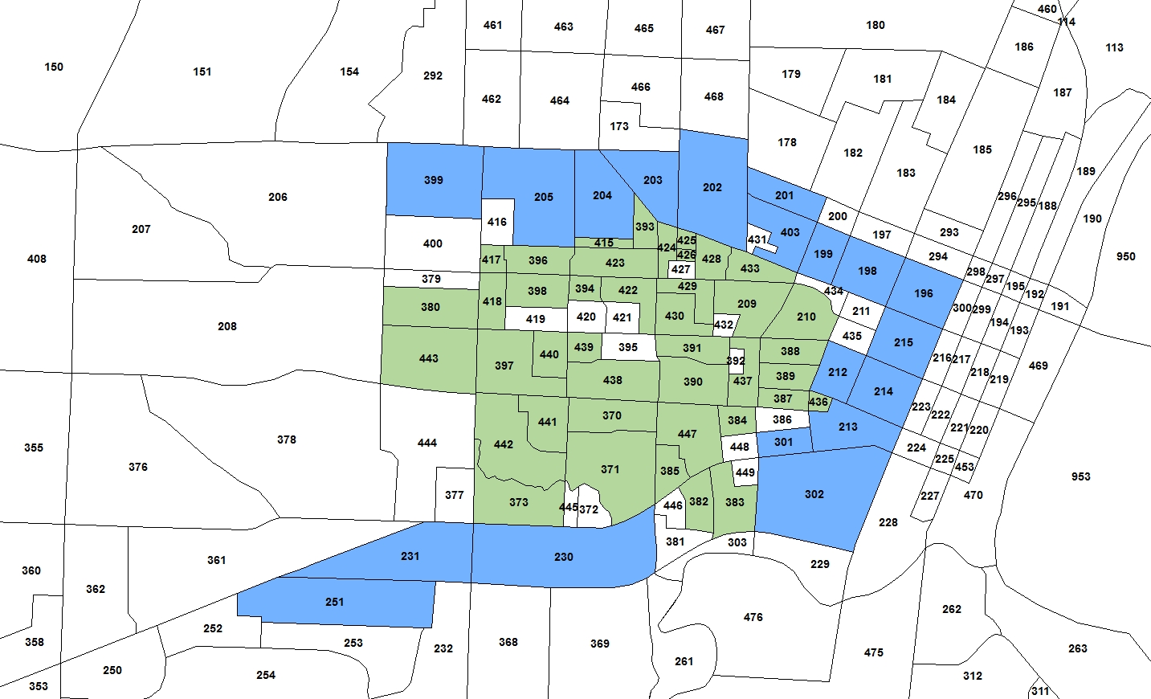

Figure : Map of Parking Lot Locations by Type

# Parking Location Choice Model General Description

The parking lot choice model was formulated so that the utility of the lot is dependent on the following variables:

* The utility of driving from the tour origin to the lot;
* The utility of walking or taking transit (such as a campus shuttle) from the lot to the on-campus destination;
* The size of the lot, which is a measurement of the potential parking opportunities; and,
* The expected availability of parking in the lot at the time of arrival, as measured by a shadow price which is explained in more detail below.

The parking lot choice model calculates the demand for each parking zone as well as the shadow prices for the next iteration. The tour mode choice model takes into account parking availability and accessibility via a parking location choice logsum term, which influences the utility of driving to campus. This is also explained in more detail below. The model is run iteratively until all lots are at or below their capacity.

## Parking Lot Choice Specification

The utility of each parking lot in the parking location choice model is calculated based on the auto accessibility from the origin zone to the lot, the walk and walk to transit accessibilities from the lot to the destination, the shadow price, whether the lot is informal (on-street off-campus) parking, and the total number of spaces in the lot. The utility calculation is shown in Formula 1 below.

$U_{L,t,M}= {EXP(AAuto}_{O,L}+ {AWalk}_{L,D}+ c_{Trans}*{ATrans}_{L,D}+ {SP}_{L,t,M}+ c_{Inf}*{Inf}_{L})*{Spaces}_{L,M}$

Equation 1: Parking Lot Utility Calculation

Where $U_{L,t,M}$ is the utility of lot L in time period t for market segment M (faculty/staff, student, or other), ${AAuto}_{O,L}$ is the SOV accessibility from origin O to lot L, ${AWalk}_{L,D}$ is the walk accessibility from lot L to destination D, $c_{Trans}$ is a transit constant specified in the properties file, ${ATrans}_{L,D}$ is the walk to transit accessibility from lot L to destination D, ${SP}_{L,t,M}$ is the current shadow price for lot L during time period t for market segment M, $c_{Inf}$ is a constant applied to informal parking, ${Inf}_{L}$ is a binary variable indicating whether the lot is informal parking, and ${Spaces}_{L,M}$ is the capacity of lot L for market segment M.

The tour origin, on-campus destination, time period, and market segment are properties of the tour that is using parking. The shadow prices, informal parking variable, and lot capacity are read in from input files, and the accessibilities are calculated within the code for the mode, lot, and destination provided. In the current implementation the walk to transit constant is set to -3.0 based on the share of parkers who utilize transit from the lot to their on-campus destination, and the informal parking constant is set to 0. If analysis shows that informal parking is being over-utilized, the informal constant can be calibrated to better match the actual share of informal parking.

## Shadow Price Calculation

The shadow price calculation penalizes lots based upon the number of parked vehicles at time t versus the total lot capacity, by market segment. The shadow price is formulated to begin pricing lots at when the demand is at 75% of supply, to reflect the expected disutility of searching for a parking space and potential longer walk to the destination. The shadow pricing calculations work iteratively, adding to the previous shadow price at the end of each full model run. The shadow price increases exponentially as the ratio of the lot demand to capacity increases. The formula for the shadow price calculation is shown below.

${SP}_{L,t,M}= {OSP}_{L,t,M}+α*\ln\left[{\left({{Demand}_{L,t,M}}/{{Spaces}_{L,M}} + 0.25\right)}^{β}\right]$

Equation 2: Parking Shadow Price Calculation

Where ${SP}_{L,t,M}$ is the shadow price for lot L in time period t for market segment M, ${OSP}_{L,t,M}$ is the old shadow price for lot L in and market segment M in time period T, $α$ is a parameter specified in the properties file, ${Demand}_{L,t,M}$ is the demand for lot L from market segment M in time period T, ${Spaces}_{L,M}$ is the capacity of lot L for market segment M, and $β$ is another parameter specified in the properties file.

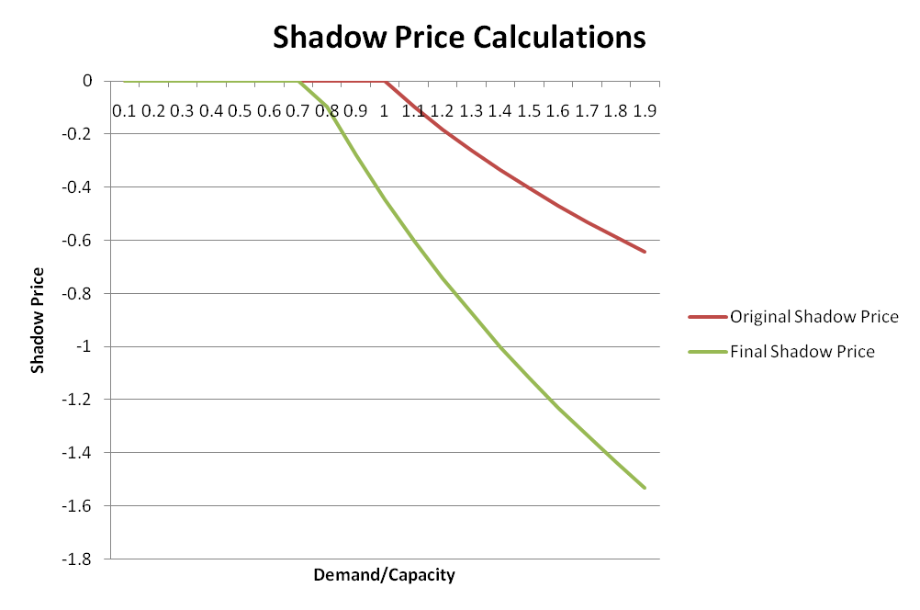Figure 2 shows a plot of how the shadow price changes as the demand to capacity ratio increases. The two lines on the graph show the simpler shadow pricing calculation originally tested and the final implementation shown in Equation 2.

Figure : Shadow Price Function

The old shadow prices are read in from the ParkingShadowPrices.csv file in the model outputs folder. If there is no file in the outputs folder, the old shadow prices are set to 0. The alpha and beta parameters are set to -1.0 and 2.0 respectively in the current model implementation. These values can be changed to alter the rate of convergence of the model by changing the amount that exceeding capacity is penalized for each lot.

## Tour Mode Choice Specification Changes

The tour mode choice was modified to account for the availability and utility of parking on campus for University tours and faculty/staff work tours, in order to reflect these variables in the choice of driving versus taking transit or a non-motorized mode. The auto mode utilities (SOV, HOV2, and HOV3+) were modified to include a parking logsum value. Therefore, if parking becomes less attractive because of increasingly restricted lot capacity, auto utilities will decrease and alternative mode usage to campus will increase.

The parking location choice logsum reflects the expected attractiveness of parking across all lots for a given market segment and time period. The logsum is formulated to consider attractiveness of parking at all lots because it is theorized that the actual parking location may not be known a priori. In other words, someone who is contemplating driving to campus may not know exactly where they might park; they only have a general impression of the availability of parking. We expect this to particularly be the case for habitual transit users who may be less familiar with the parking system. For this reason, we prefer a term which takes into account the general utility of parking at all lots for their on-campus destination, rather than any one particular lot. The parking logsum is calculated as shown in Equation 3 and then applied to each auto mode utility (drive-alone, shared-ride 2, and shared-ride 3+). Note that the logsum calculation is specific to the person’s market segment and their tour departure period.

$${Logsum}_{t,M}= \ln\left[\sum_{All Lots}{Exp\left[\left({AWalk}_{L,D}+ c_{Trans}*{ATrans}_{L,D}+ {SP}_{L,t,M}\right)*{Spaces}_{L,M}\right]}\right]$$

Equation 3: Parking Logsum Calculation

Where ${Logsum}_{t,M}$ is the parking logsum for time period t for a person in market segment M, ${AWalk}_{L,D}$ is the walk accessibility from lot L to destination D, $c_{Trans}$ is a transit constant specified in the properties file, ${ATrans}_{L,D}$ is the walk to transit accessibility from lot L to destination D, ${SP}_{L,t,M}$ is the current shadow price for lot L during time period t for market segment M, and ${Spaces}_{L,M}$ is the capacity of lot L for market segment M.

The auto modes will, therefore, be penalized if the walk and walk to transit accessibilities between the parking lots and the tour destination are low and if the shadow price is high, indicating that the lot is already at or near capacity. By penalizing auto modes where parking is not an attractive option for a tour to campus, the model is able to respond to parking limits not only by encouraging users to change to a different parking lot but also to change to a different mode in order to avoid parking.

Due to the interactions between the tour mode choice and the parking lot choice model, the same set of shadow prices was used in most iterations of the tour mode choice calibration. Once the calibration was nearly complete, the parking lot choice model results were examined to determine if any adjustments were required. In the model implementation, it is recommended that the final calibrated shadow prices be used in the initial iteration of the model. After each iteration, the lot demand should be investigated to determine whether any particular lot is over-capacity. If so, the entire model should be re-run with updated shadow prices, until all lots are at or below capacity.

# Model Calibration

Only a subset of the model components developed for the university model were calibrated for the OSU inputs. The residential location choice models for both students and faculty/staff were calibrated to match the home locations provided in the OSU Travel Survey. Although the survey data could not be used to provide tour data, the home locations were able to provide an estimate of where students live that the model was calibrated to match. Additionally, the auto ownership and mode choice models were calibrated to match the targets from the University of Oregon Travel Survey data with the OSU population and the mode choices changes that resulted from the implementation of the parking lot choice model. The parking lot choice model was also run multiple times until the demand at all lots was below the capacity for all time periods.

## Student Residential Location Choice Model

The residential location model used in the student population synthesis for the University of Oregon was applied to the OSU model with small adjustments to calibration constants. The constants were adjusted in order to match the distribution of the share of students living within a given distance of the campus (represented by TAZ 422). Table 1 shows the final calibration targets used in the student residential location choice model for Oregon State University.

Table 1: Calibration Constants for Student Residential Location Choice

|  |  |
| --- | --- |
| **Distance Category** | **Calibration Constant** |
| 0 to 1 miles | -0.51044 |
| 1 to 2 miles | -0.14346 |

Figure 3 shows the frequency distribution of students’ distance from home to campus for OSU. The targets were taken from the student home locations provided in the OSU Student Travel Survey.

## Worker Location Choice Model

Figure 3: Student Residential Location Choice Model Distance Frequency Distribution

The faculty/staff residential location choice model implementation was the same as was used in the University of Oregon model, but calibration constants specific to the Oregon State region were estimated to better match the residential distribution of faculty/staff workers. The final calibration constants used in the worker location choice model are shown in Table 2.

Table 2: Worker Location Choice Calibration Constants

|  |  |
| --- | --- |
| **Distance Category** | **Calibration Constant** |
| 0 to 1 miles | 0.205346 |
| 1 to 2 miles | 0.32556 |
| 2 to 3 miles | -0.07318 |

Using these calibration constants, the worker location choice model was implemented, and the distance frequency distribution of the distance from the worker home location to the university reference TAZ from the model and survey were compared. Figure 4 shows the distance frequency distribution for the worker residential location choice model. The model closely matches the survey data for most distance categories with a slightly higher share of predicted workers approximately 15-17 miles from campus. This discrepancy was allowed to remain in the model output based on survey bias that may have caused the home locations further away from campus to be under-represented in the survey responses.

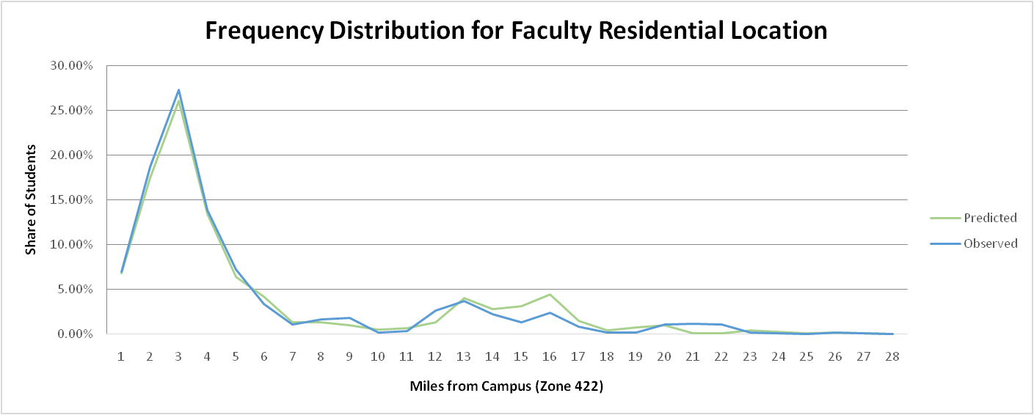

Figure 4: Faculty/Staff Residential Location Distance Frequency Distribution

## Auto Ownership Model

The auto ownership model calibration was crucial to ensuring that the other model elements were able to achieve the correct results. The auto ownership affects the modes that are available to a person, and the mode choice affects the decision of whether the tour will use a parking lot. Therefore, the auto ownership calibration was performed prior to the parking lot choice and tour mode choice calibration. The targets and final calibration constants for auto ownership model for each market (Group Quarters Student, Off-Campus Non-Family Student, Off-Campus Family Student, and Faculty/Staff) are shown in Table 3.

Table 3: Auto Ownership Calibration Targets and Constants

|  |  |  |  |
| --- | --- | --- | --- |
| **Market Segment** | **No-Auto Target Share** | **Auto Owned Target Share** | **No-Auto Calibration Constant** |
| Group Quarters | 53.9% | 46.1% | -0.3260 |
| Off-Campus Non-Family | 27.3% | 72.7% | -0.2748 |
| Off-Campus Family | 15.0% | 85.0% | -0.0143 |
| Faculty/Staff | 6.0% | 94.0% | -0.8413 |

Faculty/Staff had the highest level of auto ownership at 94%, and Group Quarters Students had the lowest at 46.1%. The calibration targets were generated from the University of Oregon Travel Survey due to the lack of data regarding auto ownership in the Oregon State University Travel Survey. The final auto ownership calibration results are shown in Figure 5. The auto ownership levels were matched for all market segments at the end of the calibration process.

## Parking Lot Choice

Figure 5: Auto Ownership Calibration Results

The parking lot choice model calibration was performed in two stages in order to account for the impact of parking lot shadow prices on the tour mode choice model. The first stage of calibration was done by running the model multiple times in order to develop a set of shadow prices that resulted in most parking lots being under capacity. Once a set of shadow prices was created that ensured that demand did not exceed capacity by more than 10 vehicles in any lot at any time of day, the tour mode choice model was calibrated using those shadow prices. After the tour mode choice calibration was completed, the updated parking demand results were checked to ensure that all lots remained under capacity for all time periods. Once this was confirmed, the demand from that final test became the parking lot choice demand, and the shadow prices were finalized to be the final shadow prices.

### Parking Lot Choice Model Results

The final implementation of the parking lot choice model resulted in many lots close to their capacity but none reaching or exceeding that capacity. The peak parking time was between 8:30 and 12:30 for most lots, and Figure 6 through Figure 9 illustrate the parking lot utilization (demand/capacity) at various time slices for faculty/staff parking during the morning peak. Figure 10 through Figure 14 show the parking lot utilization at various times throughout the morning peak for students.

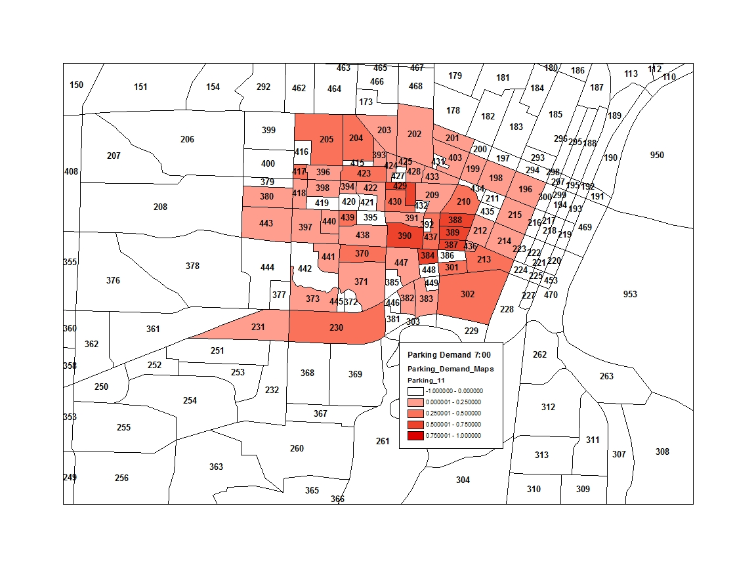

Figure 6: Faculty/Staff Parking Utilization at 7:00

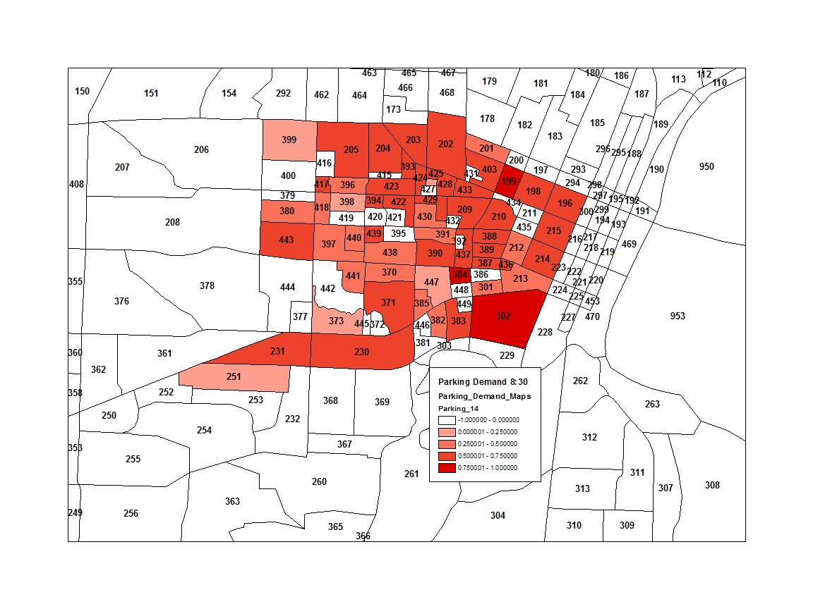

Figure 7: Faculty/Staff Parking Utilization at 8:30

### 1030Util.jpg

Figure 8: Faculty/Staff Parking Utilization at 10:30

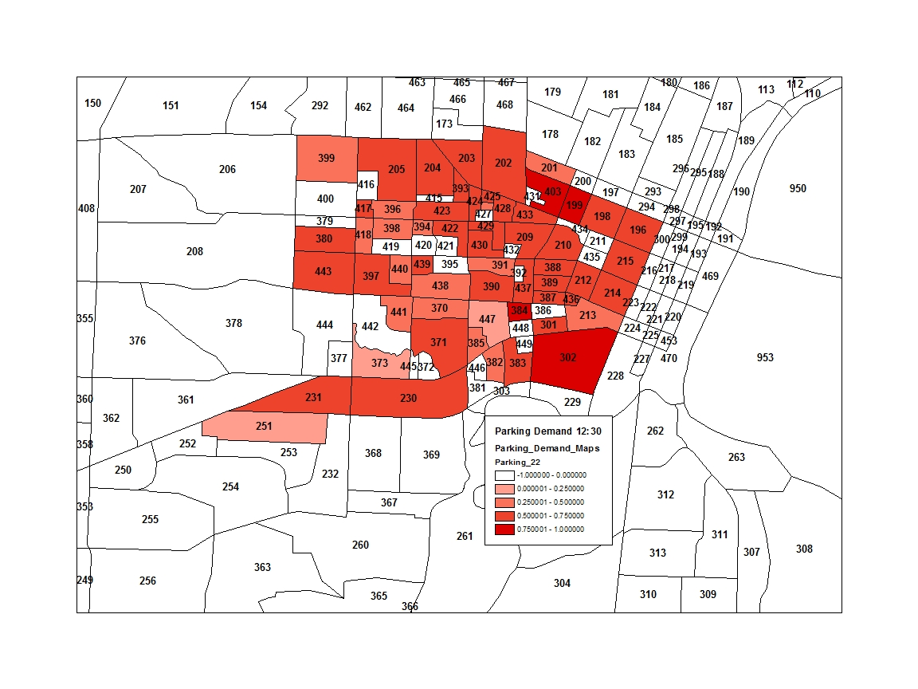

Figure 9: Faculty/Staff Parking Utilization at 12:30

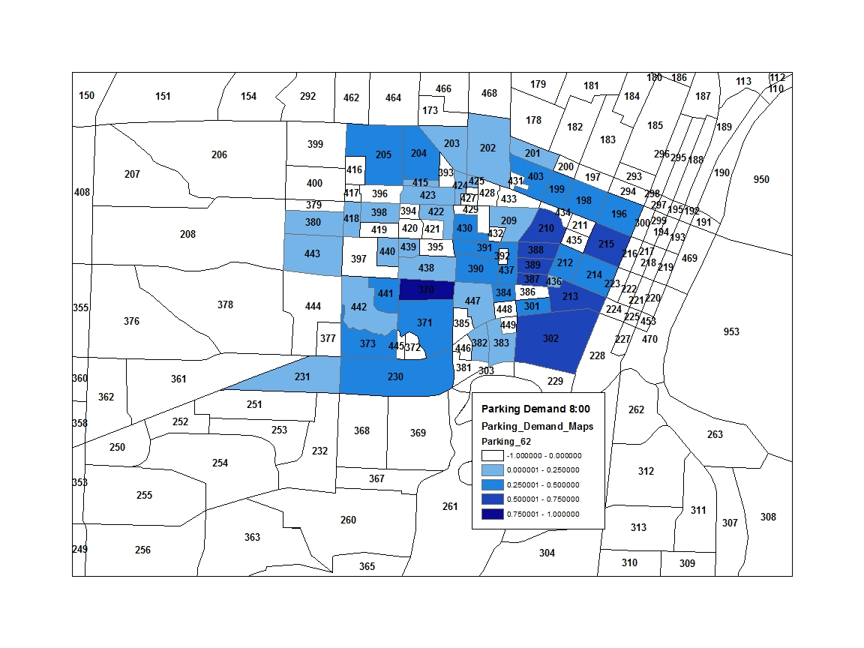

Figure 10: Student Parking Utilization at 8:00

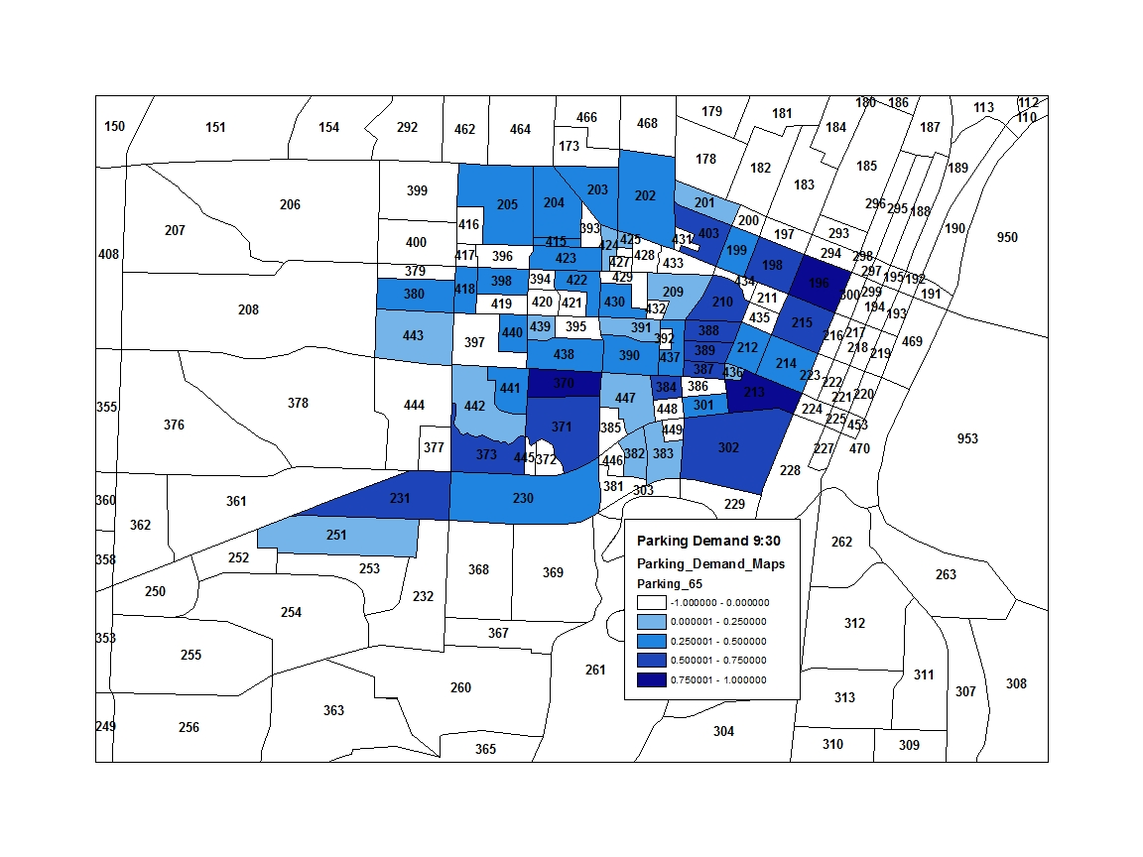

Figure 11: Student Parking Utilization at 9:30

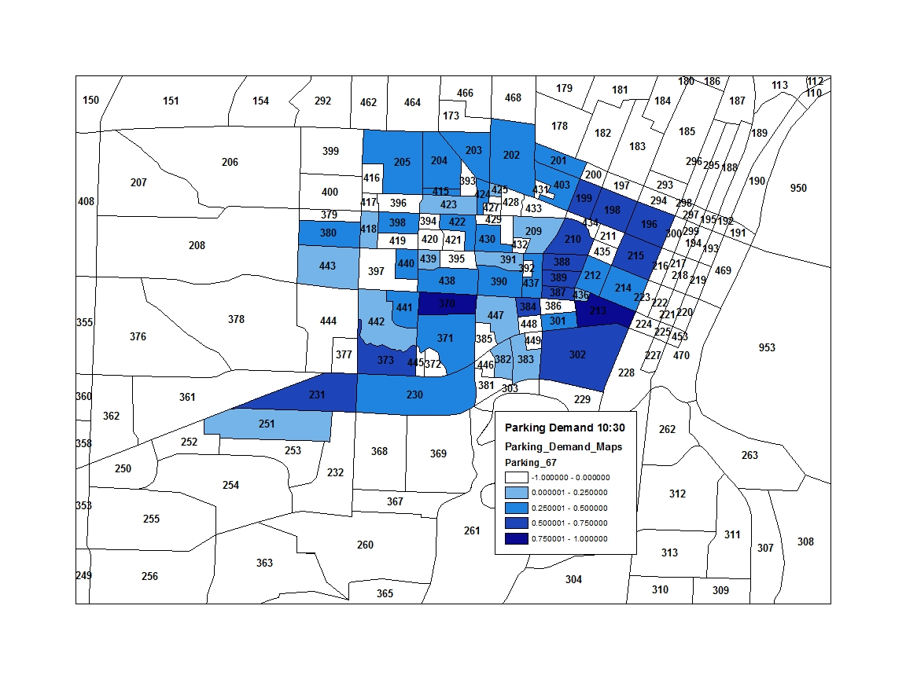

Figure 12: Student Parking Utilization at 10:30

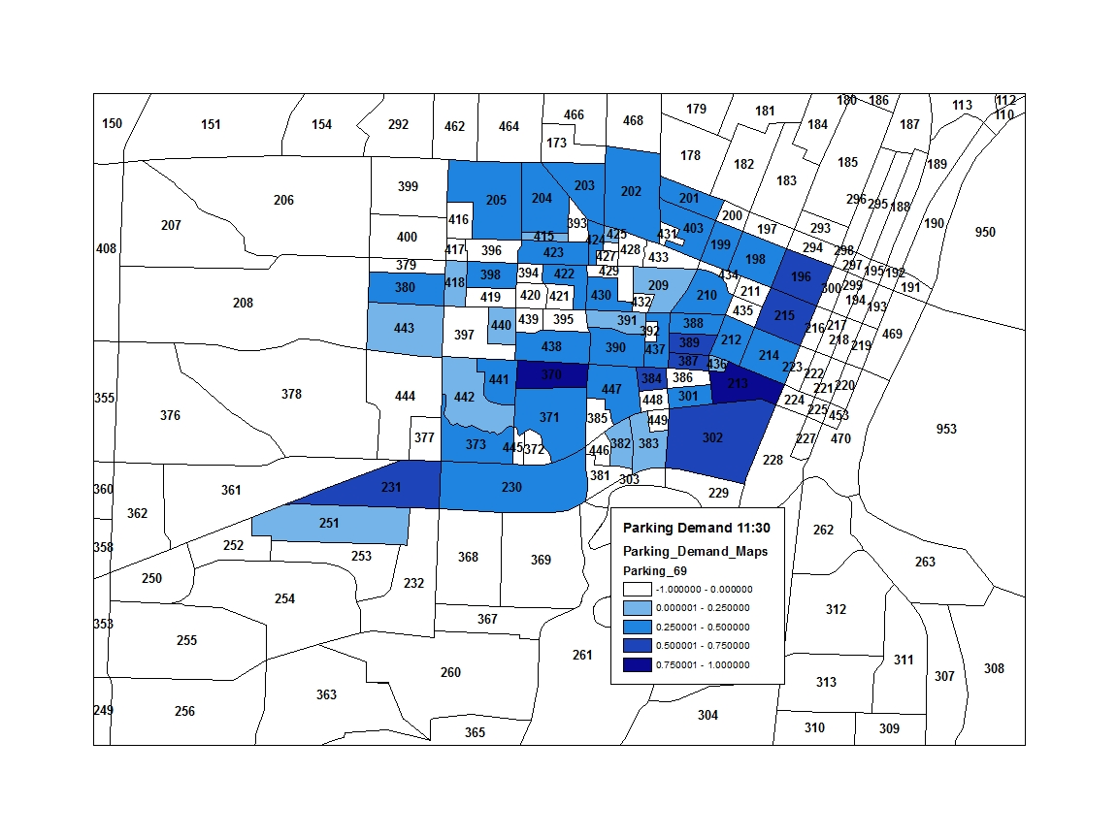

Figure 13: Student Parking Utilization at 11:30

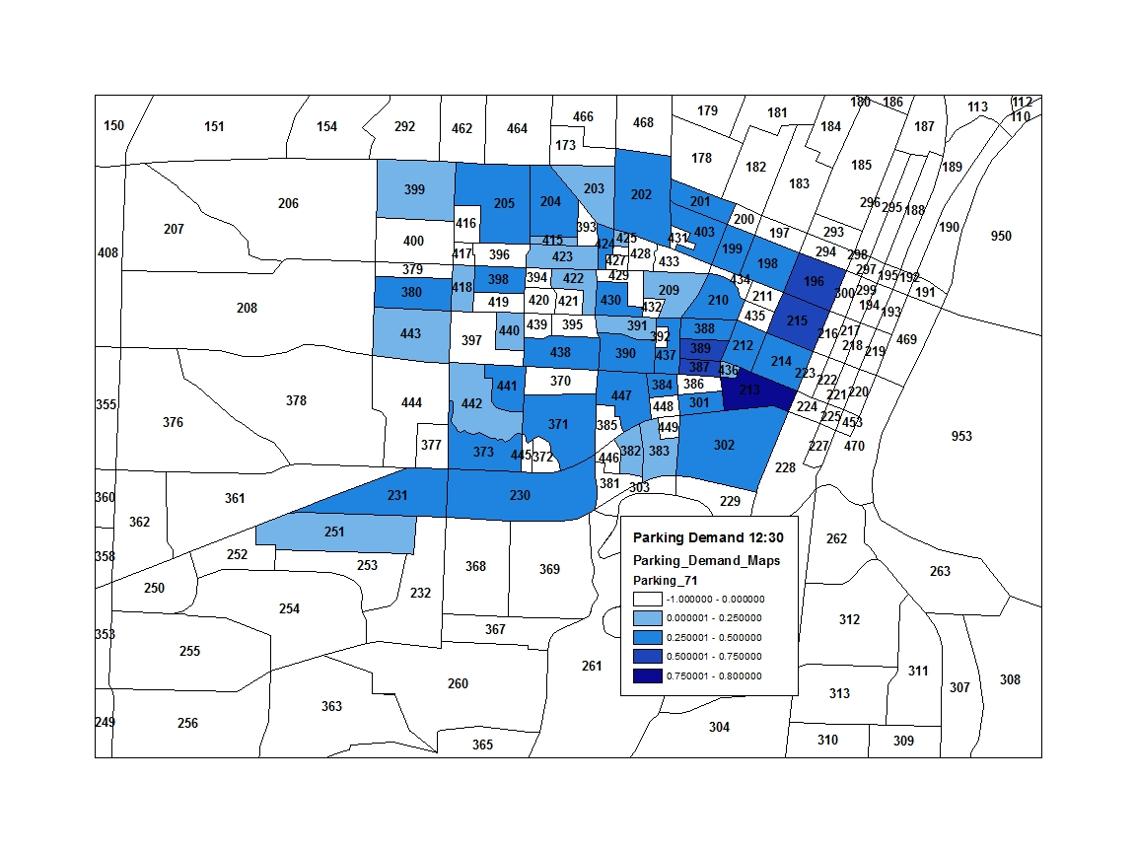

Figure 14: Student Parking Utilization 12:30

The faculty/staff parking lots fill up quickly early in the morning as people arrive at work. The parking utilization then remains relatively steady throughout the day until the end of the work day when the lots empty again. The student parking lots, on the other hand, see much more fluctuation in demand. In the early and mid-morning the lots fill up, but around mid-day the demand begins to decrease again. There is another peak later in the day as well for most lots.

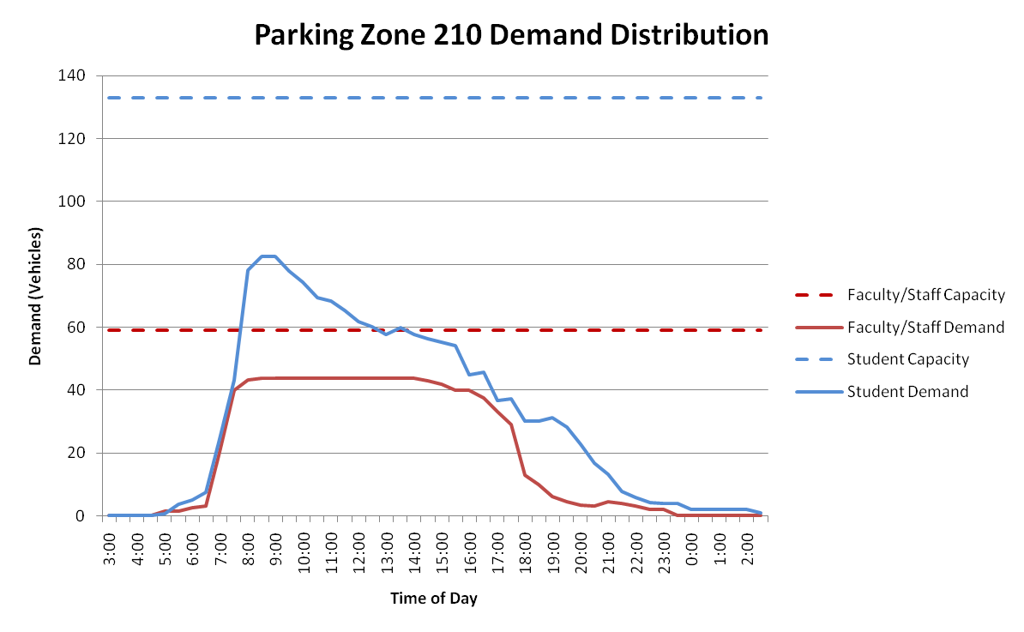The temporal distribution of demand can also be seen for specific lots by plotting the demand versus the capacity across time for faculty/staff and students. Figure 15 shows how the parking demand in zone 210 varies across the day. Both the student and faculty/staff parking peaks early in the day, but the student parking levels drop off throughout the day after that whereas the faculty/staff parking stays steady until around 4:00 pm when workers begin leaving campus to head home.

Figure : Parking Zone 210 Time of Day Demand Distribution

Zone 371 shows a similar temporal distribution of parking demand, as illustrated in Figure 16. The faculty/staff demand is almost at capacity early in the day and remains steady throughout the workday. The student demand, on the other hand, only reaches approximately half of its capacity and then decreases throughout the afternoon and evening.

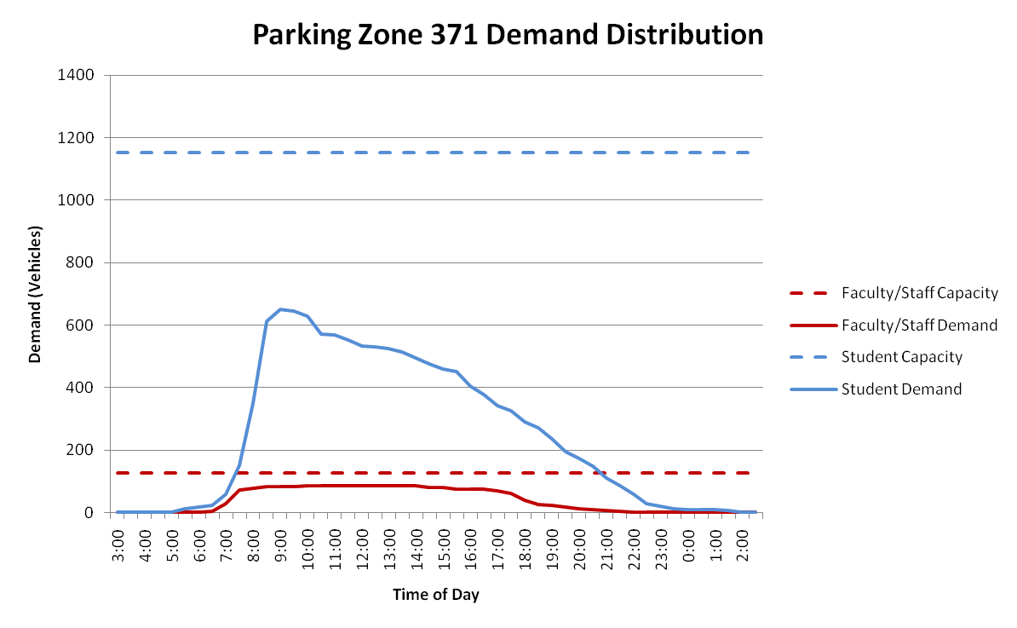

Figure : Parking Zone 371 Time of Day Demand Distribution

### Parking Lot Choice Model Calibration

The final calibrated parking lot choice model results are summarized in Table 4 and Table 5. The parking lot choice model resulted in a demand where no lot exceeds its total capacity, and some lots remained well under capacity even at the peak. Table 4 summarizes the faculty/staff parking demand data with a field indicating whether the parking in each zone is informal street parking, the faculty/staff capacity for that zone, the maximum demand and when it occurs, and the largest shadow price and when that occurs. Table 5 shows the same data for student parking. The total set of final shadow prices are provided in Appendix A.

Table 4: Faculty/Staff Parking Lot Choice Results

|  |  |  |  |  |  |  |
| --- | --- | --- | --- | --- | --- | --- |
| **Parking Zone** | **Street Parking** | **Capacity** | **Maximum Demand** | **Max Demand Time** | **Maximum Shadow Price** | **Max Shadow Price Time** |
| 196 | Yes | 50 | 33 | 8:30 | -9.98611 | 11:00 |
| 198 | Yes | 50 | 35 | 9:00 | -8.76637 | 11:00 |
| 199 | Yes | 30 | 25 | 8:30 | -7.46175 | 10:00 |
| 201 | Yes | 35 | 16 | 10:00 | -5.45931 | 13:00 |
| 202 | Yes | 110 | 66 | 11:30 | -8.25501 | 11:30 |
| 203 | Yes | 100 | 63 | 9:30 | -8.04574 | 11:30 |
| 204 | Yes | 200 | 135 | 8:30 | -8.41912 | 11:30 |
| 205 | Yes | 110 | 80 | 10:30 | -8.38597 | 11:30 |
| 209 | No | 48 | 30 | 9:30 | -9.76325 | 11:30 |
| 210 | No | 59 | 44 | 8:30 | -12.1359 | 13:00 |
| 212 | Yes | 30 | 16 | 12:30 | -7.35442 | 11:30 |
| 213 | Yes | 10 | 4 | 8:00 | -10.7122 | 12:30 |
| 214 | Yes | 50 | 30 | 12:30 | -7.56335 | 10:30 |
| 215 | Yes | 30 | 22 | 10:30 | -6.67486 | 11:00 |
| 230 | Yes | 50 | 37 | 13:00 | -7.70772 | 11:30 |
| 231 | Yes | 40 | 28 | 9:30 | -7.88034 | 11:30 |
| 251 | Yes | 40 | 4 | 11:30 | -1.26172 | 13:00 |
| 301 | Yes | 10 | 6 | 10:30 | -9.314 | 12:30 |
| 302 | Yes | 150 | 120 | 10:30 | -8.87766 | 10:30 |
| 370 | No | 46 | 22 | 7:30 | -6.1793 | 10:30 |
| 371 | No | 126 | 87 | 10:30 | -8.46661 | 12:30 |
| 373 | No | 2 | 1 | 7:00 | -7.64337 | 11:30 |
| 380 | No | 91 | 50 | 10:30 | -5.59654 | 11:30 |
| 382 | No | 149 | 64 | 9:30 | -4.9543 | 11:30 |
| 383 | No | 28 | 17 | 11:30 | -4.80803 | 12:30 |
| 384 | No | 105 | 88 | 10:00 | -11.0163 | 11:30 |
| 385 | No | 2 | 1 | 7:30 | -6.59688 | 9:00 |
| 387 | No | 3 | 2 | 7:00 | -8.93939 | 11:30 |
| 388 | No | 30 | 18 | 8:00 | -10.8607 | 11:30 |
| 389 | No | 122 | 91 | 11:30 | -10.29 | 11:30 |
| 390 | No | 104 | 67 | 10:30 | -9.26337 | 11:30 |
| 391 | No | 5 | 2 | 9:30 | -11.9705 | 9:30 |
| 393 | No | 115 | 74 | 8:30 | -9.16619 | 11:30 |
| 394 | No | 86 | 44 | 8:00 | -5.88453 | 11:30 |
| 396 | No | 27 | 14 | 11:00 | -5.07722 | 12:30 |
| 397 | No | 28 | 14 | 12:30 | -5.29865 | 11:30 |
| 398 | No | 39 | 15 | 11:30 | -3.89867 | 12:30 |
| 399 | Yes | 10 | 4 | 12:30 | -3.57569 | 14:30 |
| 403 | Yes | 40 | 32 | 13:00 | -8.63428 | 11:30 |
| 415 | No | 0 | 0 | n.a. | 0 | n.a. |
| 417 | No | 34 | 22 | 9:00 | -7.14381 | 11:30 |
| 418 | No | 107 | 52 | 10:00 | -5.65907 | 11:30 |
| 422 | No | 155 | 88 | 9:30 | -6.51959 | 11:30 |
| 423 | No | 102 | 59 | 10:00 | -7.33779 | 11:30 |
| 424 | No | 172 | 102 | 10:30 | -7.48635 | 11:30 |
| 425 | No | 128 | 82 | 11:30 | -7.35253 | 11:30 |
| 426 | No | 4 | 1 | 10:00 | -4.52579 | 13:00 |
| 428 | No | 41 | 31 | 10:30 | -8.53431 | 9:30 |
| 429 | No | 4 | 3 | 7:00 | -7.35167 | 13:00 |
| 430 | No | 78 | 42 | 14:30 | -12.2674 | 11:30 |
| 433 | No | 41 | 29 | 9:00 | -8.82276 | 12:30 |
| 436 | No | 90 | 49 | 10:00 | -5.76918 | 13:00 |
| 437 | No | 144 | 83 | 10:30 | -9.7355 | 11:30 |
| 438 | No | 24 | 8 | 8:30 | -7.36984 | 12:30 |
| 439 | No | 18 | 13 | 8:30 | -5.4675 | 11:30 |
| 440 | No | 113 | 49 | 9:30 | -5.10983 | 10:30 |
| 441 | No | 21 | 7 | 9:30 | -5.70099 | 10:30 |
| 442 | No | 0 | 0 | n.a. | 0 | n.a. |
| 443 | No | 101 | 54 | 12:30 | -5.06663 | 12:30 |
| 447 | No | 59 | 1 | 7:00 | 0 | n.a. |

Table 5: Student Parking Lot Choice Results

|  |  |  |  |  |  |  |
| --- | --- | --- | --- | --- | --- | --- |
| **Parking Zone** | **Street Parking** | **Capacity** | **Maximum Demand** | **Max Demand Time** | **Maximum Shadow Price** | **Max Shadow Price Time** |
| 196 | Yes | 50 | 38 | 9:30 | -8.7471 | 10:00 |
| 198 | Yes | 50 | 29 | 10:00 | -8.5581 | 10:00 |
| 199 | Yes | 30 | 16 | 10:30 | -4.61504 | 13:30 |
| 201 | Yes | 35 | 15 | 13:30 | -0.47732 | 13:30 |
| 202 | Yes | 110 | 53 | 9:00 | -6.87795 | 10:00 |
| 203 | Yes | 100 | 40 | 9:00 | -6.45125 | 13:30 |
| 204 | Yes | 200 | 91 | 9:00 | -6.12497 | 10:00 |
| 205 | Yes | 110 | 50 | 9:00 | -7.5437 | 9:30 |
| 209 | No | 11 | 3 | 8:30 | -8.12098 | 11:30 |
| 210 | No | 133 | 83 | 8:30 | -9.70822 | 9:30 |
| 212 | Yes | 30 | 13 | 8:30 | -8.61076 | 9:30 |
| 213 | Yes | 10 | 9 | 9:00 | -9.1231 | 10:00 |
| 214 | Yes | 50 | 24 | 9:00 | -8.97847 | 11:00 |
| 215 | Yes | 30 | 23 | 9:00 | -9.44864 | 9:30 |
| 230 | Yes | 50 | 23 | 9:00 | -8.24605 | 13:30 |
| 231 | Yes | 40 | 22 | 9:30 | -6.87266 | 13:30 |
| 251 | Yes | 40 | 2 | 10:00 | 0 | n.a. |
| 301 | Yes | 10 | 5 | 8:00 | -8.96485 | 13:30 |
| 302 | Yes | 150 | 97 | 9:00 | -9.98616 | 9:30 |
| 370 | No | 1 | 1 | 7:30 | -6.66714 | 13:00 |
| 371 | No | 1,151 | 649 | 9:00 | -6.75995 | 9:30 |
| 373 | No | 55 | 33 | 9:30 | -7.19142 | 10:30 |
| 380 | No | 91 | 34 | 9:30 | -2.81301 | 11:30 |
| 382 | No | 149 | 31 | 11:30 | -2.09913 | 13:30 |
| 383 | No | 28 | 4 | 10:00 | -1.17261 | 13:30 |
| 384 | No | 37 | 25 | 9:30 | -9.73224 | 11:30 |
| 385 | No | 2 | 0 | 3:00 | -3.31646 | 7:30 |
| 387 | No | 388 | 238 | 8:00 | -9.28673 | 9:30 |
| 388 | No | 85 | 47 | 9:00 | -8.96251 | 9:30 |
| 389 | No | 372 | 246 | 9:00 | -9.15054 | 10:00 |
| 390 | No | 82 | 31 | 10:00 | -8.64949 | 9:30 |
| 391 | No | 2 | 1 | 5:30 | -17.4307 | 14:00 |
| 393 | No | 2 | 0 | n.a. | -7.79945 | 12:00 |
| 394 | No | 5 | 0 | n.a. | -6.79209 | 13:00 |
| 396 | No | 6 | 0 | n.a. | -6.24275 | 14:00 |
| 397 | No | 0 | 0 | n.a. | 0 | n.a. |
| 398 | No | 241 | 85 | 10:00 | -3.23483 | 11:00 |
| 399 | Yes | 10 | 1 | 12:30 | -2.65597 | 15:30 |
| 403 | Yes | 40 | 23 | 9:00 | -7.67906 | 13:00 |
| 415 | No | 171 | 47 | 9:30 | -3.37202 | 9:30 |
| 417 | No | 0 | 0 | n.a. | 0 | n.a. |
| 418 | No | 203 | 58 | 9:00 | -3.52799 | 13:30 |
| 422 | No | 67 | 19 | 9:30 | -3.7187 | 10:00 |
| 423 | No | 81 | 24 | 9:00 | -3.43814 | 9:30 |
| 424 | No | 8 | 3 | 10:00 | -6.62532 | 12:30 |
| 425 | No | 10 | 1 | 9:00 | -6.69883 | 11:30 |
| 426 | No | 0 | 0 | n.a. | 0 | n.a. |
| 428 | No | 2 | 0 | n.a. | -15.4891 | 13:30 |
| 429 | No | 4 | 1 | 18:30 | -8.40155 | 12:30 |
| 430 | No | 78 | 37 | 8:30 | -11.5427 | 13:30 |
| 433 | No | 4 | 0 | n.a. | -11.5081 | 13:00 |
| 436 | No | 90 | 22 | 12:30 | -1.05865 | 12:30 |
| 437 | No | 39 | 18 | 8:00 | -10.034 | 9:30 |
| 438 | No | 95 | 29 | 10:00 | -2.81582 | 10:00 |
| 439 | No | 5 | 1 | 7:30 | -5.10815 | 12:00 |
| 440 | No | 60 | 17 | 8:30 | -3.77144 | 14:00 |
| 441 | No | 21 | 7 | 8:30 | -3.38643 | 13:30 |
| 442 | No | 94 | 16 | 13:30 | -2.65897 | 13:30 |
| 443 | No | 85 | 18 | 10:00 | -2.66933 | 13:30 |
| 447 | No | 1,133 | 336 | 13:30 | 0 | n.a. |

In many cases, the maximum demand and largest shadow price did not occur in the same time period. This is due to the fact that the shadow prices are additive across iterations. While in this final iteration the maximum demand was in that time period, if the maximum demand was in a different period in previous iterations, the shadow price for that time period would have increased for that time.

## Tour Mode Choice

In order to calibrate the Tour Mode Choice model, a final set of parking shadow prices were developed which resulted in most lots being under capacity for all time periods. These shadow prices were used in each iteration of the Tour Mode Choice (and Trip Mode Choice) calibration to ensure that any variation in tour mode selection could be accounted for by the calibration constants rather than parking shadow prices. At the end of the Tour Mode Choice calibration process the parking lot demand was re-evaluated to determine if additional iterations of parking lot and tour mode calibration were required. The Tour Mode Choice calibration generally decreased the rate at which auto modes were used for student university tours and faculty/staff work tours, so the previously-developed parking shadow prices were still applicable.

The Tour Mode Choice model was calibrated by tour purpose and auto ownership level for both faculty/staff and student tours. The calibration targets for student tours are shown in Table 6, and the calibration targets for faculty/staff tours are shown in Table 7. Due to the nature of the Oregon State University Travel Survey, tour mode was not able to be determined for OSU student or faculty/staff travel. Therefore, the tour mode choice targets were based on the University of Oregon Travel Survey data. The University of Oregon region provided more detail on the transit modes than was available in the Oregon State University region. Therefore, for the Oregon State University Tour and Trip Mode calibration all transit modes were combined into one general Transit mode.

Table 6: Student Tour Mode Choice Calibration Targets

|  |  |  |  |  |  |  |  |  |  |
| --- | --- | --- | --- | --- | --- | --- | --- | --- | --- |
| **Tour Mode** | **University** | | **Work** | | **Maintenance** | | **Discretionary** | | |
| **No Auto** | **Auto** | **No Auto** | **Auto** | **No Auto** | **Auto** | **No Auto** | **Auto** |
| Drive Alone | -- | 29.5% | -- | 29.5% | -- | 29.5% | -- | 20.9% |
| HOV2 | 4.3% | 13.2% | 4.3% | 13.2% | 4.3% | 13.2% | 23.0% | 34.2% |
| HOV3+ | -- | -- | -- | -- | -- | -- | 1.7% | 3.3% |
| Walk | 40.4% | 16.8% | 40.4% | 16.8% | 40.4% | 16.8% | 51.7% | 31.7% |
| Bike | 46.5% | 25.7% | 46.5% | 25.7% | 46.5% | 25.7% | 4.9% | 7.3% |
| Transit | 8.8% | 14.8% | 8.8% | 14.8% | 8.8% | 14.8% | 18.8% | 2.6% |
| Total | 100% | 100% | 100% | 100% | 100% | 100% | 100% | 100% |

Table 7: Faculty/Staff Tour Mode Choice Calibration Targets

|  |  |  |  |
| --- | --- | --- | --- |
| **Tour Mode** | **Work** | | |
| **No Auto** | **Auto** |
| Drive Alone | -- | 35.9% |
| HOV2 | 9.4% | 21.1% |
| HOV3+ | -- | 3.9% |
| Walk | 9.4% | 3.1% |
| Bike | 49.3% | 22.8% |
| Transit | 31.9% | 13.2% |
| Total | 100% | 100% |

Due to the fact that the targets developed were based on a different student population, the mode choice calibration was only used to match mode shares, not total tours. The final mode choice calibration constants for student tours are shown in Table 8, and the final mode choice calibration constants for faculty/staff tours are shown in Table 9.

Table 8: Student Tour Mode Choice Calibration Constants

|  |  |  |  |  |  |  |  |  |  |
| --- | --- | --- | --- | --- | --- | --- | --- | --- | --- |
| **Tour Mode** | **University** | | **Work** | | **Maintenance** | | **Discretionary** | | |
| **No Auto** | **Auto** | **No Auto** | **Auto** | **No Auto** | **Auto** | **No Auto** | **Auto** |
| Drive Alone | 0 | 0 | 0 | 0 | 0 | 0 | 0 | 0 |
| HOV2 | 0 | 0.2456 | 0 | -0.4212 | 0 | 0.4015 | 0 | 0.4889 |
| HOV3+ | 0.6377 | 0.6785 | -999 | -999 | -999 | 0.9832 | 0.6860 | 0.8233 |
| Walk | 12.8063 | 10.3986 | 3.7241 | 2.0720 | 0.8746 | 0.5117 | 0.7773 | 1.5445 |
| Bike | 11.3493 | 8.5463 | 2.9529 | 1.5181 | 0.3154 | -0.0563 | -0.7538 | 0.4149 |
| Transit | 16.1638 | 14.4885 | 4.7116 | 4.6445 | 3.5353 | 2.6864 | 3.0109 | 2.8748 |

Table 9: Faculty/Staff Tour Mode Choice Calibration Constants

|  |  |  |  |
| --- | --- | --- | --- |
| **Tour Mode** | **Work** | | |
| **No Auto** | **Auto** |
| Drive Alone | 0 | 0 |
| HOV2 | 0 | -0.0968 |
| HOV3+ | -999 | 0.6207 |
| Walk | 16.4328 | 8.1578 |
| Bike | 14.6245 | 7.3974 |
| Transit | 25.2684 | 14.1856 |

The calibration constants for Walk, Bike, and Transit modes are much larger than others for tours with Oregon State University as the destination (student university tours and faculty/staff work tours). This is due to a combination of two factors. First, the Oregon State University campus is larger than the University of Oregon campus for which the models were estimated. This results in longer tours to and from campus, which would penalize the non-auto modes. Additionally, the models were previously estimated and calibrated without the parking lot choice logsums. The addition of the logsums changes the relative utilities calculated and requires larger calibration constants to adjust the mode shares.

When the calibration constants are applied with the final shadow prices, the shares of all tour modes are within 3% of the target shares for student tours and within 6% of target shares for faculty/staff tours. The absolute differences in tour mode shares for student tours are shown in Table 10, and the absolute differences in tour mode shares for faculty/staff tours are shown in Table 11.

Table 10: Absolute Difference in Student Tour Mode Shares

|  |  |  |  |  |  |  |  |  |  |
| --- | --- | --- | --- | --- | --- | --- | --- | --- | --- |
| **Tour Mode** | **University** | | **Work** | | **Maintenance** | | **Discretionary** | | |
| **No Auto** | **Auto** | **No Auto** | **Auto** | **No Auto** | **Auto** | **No Auto** | **Auto** |
| Drive Alone | 0.0% | 1.7% | 0.0% | 0.9% | 0.0% | -0.2% | 0.0% | 0.0% |
| HOV2 | 0.5% | -0.7% | 0.0% | -3.0% | 0.3% | 0.9% | -0.7% | 0.2% |
| HOV3+ | 0.1% | 0.0% | 0.0% | 0.0% | 0.0% | -0.3% | 0.8% | 0.0% |
| Walk | -0.9% | -1.5% | 0.0% | 0.5% | 0.8% | -0.1% | 0.0% | -0.4% |
| Bike | -0.6% | -0.1% | 0.2% | 1.0% | -1.3% | 0.3% | 0.0% | 0.2% |
| Transit | 1.0% | 0.6% | -0.1% | 0.5% | 0.1% | -0.5% | -0.2% | 0.0% |
| Total | 0.0% | 0.0% | 0.0% | 0.0% | 0.0% | 0.0% | 0.0% | 0.0% |

Table 11: Absolute Difference in Faculty/Staff Tour Mode Shares

|  |  |  |  |
| --- | --- | --- | --- |
| **Tour Mode** | **Work** | | |
| **No Auto** | **Auto** |
| Drive Alone | 0.0% | 1.9% |
| HOV2 | 1.1% | 1.2% |
| HOV3+ | 0.0% | -0.2% |
| Walk | 0.1% | 0.0% |
| Bike | 4.3% | -0.4% |
| Transit | -5.6% | -2.6% |
| Total | 0.0% | 0.0% |

For faculty/staff tours the calibration process was unable to match the bike and transit mode shares for faculty/staff with no auto available. The share of faculty/staff with no auto was only 6%, however, so the differences are equivalent to only 13 bike tours and 17 transit tours.

## Trip Mode Choice

After the Tour Mode Choice calibration was completed, the Trip Mode Choice Model was calibrated using the same final parking shadow prices in order to keep the tour mode choices consistent. The Trip Mode Choice Model was calibrated for students by university and non-university tours and for faculty/staff for work tours. As with the tour mode choice, the calibration targets were derived from the University of Oregon model, so only mode shares and comparison of mode shares are shown here due to the fact that total trips do not match between the two models. The trip mode choice calibration targets for student university tours are shown in Table 12, and the calibration targets for student non-university tours are shown in Table 13. The calibration targets for faculty/staff work tours are shown in Table 14. The modes from the University of Oregon data have been aggregated so that for both tours and trips only one general transit mode is used. Cells shaded in grey indicate tour/trip mode combinations which are not permitted due to the mode choice hierarchy.

Table 12: Student University Tour Trip Mode Choice Calibration Targets

|  |  |  |  |  |  |  |
| --- | --- | --- | --- | --- | --- | --- |
| **Tour Mode** | **Trip Mode** | | | | | |
| **Drive Alone** | **HOV 2** | **HOV 3+** | **Walk** | **Bike** | **Transit** |
| Drive Alone | 85.1% | -- | -- | 14.9% | -- | -- |
| HOV2 | 9.0% | 53.3% | -- | 37.7% | -- | -- |
| HOV3+ | 3.0% | 3.9% | 46.6% | 46.5% | -- | -- |
| Walk | -- | -- | -- | 100.0% | -- | -- |
| Bike | -- | -- | -- | 25.3% | 74.7% | -- |
| Transit | -- | 8.9% | -- | 37.4% | 1.5% | 52.2% |

Table 13: Student Non-University Tour Trip Mode Choice Calibration Targets

|  |  |  |  |  |  |  |
| --- | --- | --- | --- | --- | --- | --- |
| **Tour Mode** | **Trip Mode** | | | | | |
| **Drive Alone** | **HOV 2** | **HOV 3+** | **Walk** | **Bike** | **Transit** |
| Drive Alone | 91.9% | -- | -- | 8.1% | -- | -- |
| HOV2 | 12.7% | 76.7% | -- | 10.6% | -- | -- |
| HOV3+ | 11.0% | 15.0% | 66.9% | 7.1% | -- | -- |
| Walk | -- | -- | -- | 100.0% | -- | -- |
| Bike | -- | -- | -- | 11.9% | 88.1% | -- |
| Transit | -- | 15.9% | -- | 32.9% | 2.5% | 48.8% |

Table 14: Faculty/Staff Work Tour Trip Mode Choice Calibration Targets

|  |  |  |  |  |  |  |
| --- | --- | --- | --- | --- | --- | --- |
| **Tour Mode** | **Trip Mode** | | | | | |
| **Drive Alone** | **HOV 2** | **HOV 3+** | **Walk** | **Bike** | **Transit** |
| Drive Alone | 82.9% | -- | -- | 17.1% | -- | -- |
| HOV2 | 25.3% | 50.3% | -- | 24.3% | -- | -- |
| HOV3+ | 9.0% | 12.6% | 30.9% | 47.6% | -- | -- |
| Walk | -- | -- | -- | 100.0% | -- | -- |
| Bike | -- | -- | -- | 34.2% | 65.8% | -- |
| Transit | -- | 19.5% | -- | 29.0% | -- | 51.4% |

Based on those target shares, the calibration constants were developed for student university and non-university tours as well as faculty/staff work tours. The trip/tour mode combinations with -999 as the constant were either not permitted due to the mode hierarchy or were not observed in the survey data. The only exception to this was the HOV2 trip constants for Bike tours. Due to limitations on trip mode availability, the constants for HOV2 trips on Bike tours could not be set to -999. Instead it was set to -150 so that HOV2 trips were highly penalized but not prohibited. The trip mode choice calibration constants are shown in Table 15 to Table 17.

Table 15: Student University Tour Trip Mode Choice Calibration Constants

|  |  |  |  |  |  |  |
| --- | --- | --- | --- | --- | --- | --- |
| **Tour Mode** | **Trip Mode** | | | | | |
| **Drive Alone** | **HOV 2** | **HOV 3+** | **Walk** | **Bike** | **Transit** |
| Drive Alone | 0 | -999 | -999 | 0.2437 | -999 | -999 |
| HOV2 | -1.0632 | 0 | -999 | 1.8796 | -999 | -999 |
| HOV3+ | -1.6864 | -1.8771 | 0 | 2.2668 | -999 | -999 |
| Walk | -999 | -999 | -999 | 0 | -999 | -999 |
| Bike | -999 | -150 | -999 | 1.4260 | 0 | -999 |
| Transit | -999 | -5.4756 | -999 | -1.8091 | -5.4758 | 0 |

Table 16: Student Non-University Tour Trip Mode Choice Calibration Constants

|  |  |  |  |  |  |  |
| --- | --- | --- | --- | --- | --- | --- |
| **Tour Mode** | **Trip Mode** | | | | | |
| **Drive Alone** | **HOV 2** | **HOV 3+** | **Walk** | **Bike** | **Transit** |
| Drive Alone | 0 | -999 | -999 | 0 | -999 | -999 |
| HOV2 | -1.0033 | 0 | -999 | -0.7367 | -999 | -999 |
| HOV3+ | -1.3265 | -1.0631 | 0 | -1.7454 | -999 | -999 |
| Walk | -999 | -999 | -999 | 0 | -999 | -999 |
| Bike | -999 | -150 | -999 | 0.1230 | 0 | -999 |
| Transit | -999 | -4.5984 | -999.0000 | -1.8003 | -4.7051 | 0 |

Table 17: Faculty/Staff Work Tour Trip Mode Choice Calibration Constants

|  |  |  |  |  |  |  |
| --- | --- | --- | --- | --- | --- | --- |
| **Tour Mode** | **Trip Mode** | | | | | |
| **Drive Alone** | **HOV 2** | **HOV 3+** | **Walk** | **Bike** | **Transit** |
| Drive Alone | 0 | -999 | -999 | 1.3728 | -999 | -999 |
| HOV2 | -0.5668 | 0 | -999 | 2.4270 | -999 | -999 |
| HOV3+ | -1.1212 | -0.8483 | 0 | 4.5386 | -999 | -999 |
| Walk | -999 | -999 | -999 | 0 | -999 | -999 |
| Bike | -999 | -150 | -999 | 2.4618 | 0 | -999 |
| Transit | -999 | -5.065 | -999 | -1.3556 | -999 | 0 |

With those calibration constants applied, the tour/trip mode shares were all within 2% of the target shares. The absolute differences between the modeled and target shares for trip modes are shown in Table 18 toTable 20 below.

Table 18: Student University Tour Absolute Difference in Trip Mode Shares

|  |  |  |  |  |  |  |
| --- | --- | --- | --- | --- | --- | --- |
| **Tour Mode** | **Trip Mode** | | | | | |
| **Drive Alone** | **HOV 2** | **HOV 3+** | **Walk** | **Bike** | **Transit** |
| Drive Alone | 0.0% | -- | -- | 0.0% | -- | -- |
| HOV2 | 0.1% | -0.1% | -- | 0.0% | -- | -- |
| HOV3+ | 0.1% | -0.1% | 0.3% | -0.2% | -- | -- |
| Walk | -- | -- | -- | 0.0% | -- | -- |
| Bike | -- | -- | -- | 0.0% | 0.0% | -- |
| Transit | -- | 0.0% | -- | 0.0% | 0.0% | 0.0% |

Table 19: Student Non-University Tour Absolute Difference in Trip Mode Shares

|  |  |  |  |  |  |  |
| --- | --- | --- | --- | --- | --- | --- |
| **Tour Mode** | **Trip Mode** | | | | | |
| **Drive Alone** | **HOV 2** | **HOV 3+** | **Walk** | **Bike** | **Transit** |
| Drive Alone | 0.0% | -- | -- | 0.0% | -- | -- |
| HOV2 | 0.0% | 0.0% | -- | 0.0% | -- | -- |
| HOV3+ | -2.2% | 0.5% | 1.7% | 0.0% | -- | -- |
| Walk | -- | -- | -- | 0.0% | -- | -- |
| Bike | -- | -- | -- | 0.0% | 0.0% | -- |
| Transit | -- | 0.0% | -- | 0.0% | 0.0% | 0.0% |

Table 20: Faculty/Staff Work Tour Absolute Difference in Trip Mode Shares

|  |  |  |  |  |  |  |
| --- | --- | --- | --- | --- | --- | --- |
| **Tour Mode** | **Trip Mode** | | | | | |
| **Drive Alone** | **HOV 2** | **HOV 3+** | **Walk** | **Bike** | **Transit** |
| Drive Alone | 0.0% | -- | -- | 0.0% | -- | -- |
| HOV2 | 0.0% | -0.1% | -- | 0.1% | -- | -- |
| HOV3+ | -0.3% | -0.4% | -0.6% | 1.2% | -- | -- |
| Walk | -- | -- | -- | 0.0% | -- | -- |
| Bike | -- | -- | -- | 0.1% | -0.1% | -- |
| Transit | -- | 0.0% | -- | -0.1% | -- | 0.0% |

The largest discrepancies between the model results and the targets were for student non-university and faculty/staff HOV3+ tours. This was the smallest segment for all markets, so the differences in shares equate to fewer total trips than for any other mode.Parking Lot Choice Model User’s Guide

The overall setup and process of running the university model remains the same when a set of calibrated shadow prices is provided. The only changes in that case are to the input files required by the model and the set of output files produced by the model. This section describes the changes to both the input and output files to allow for the modeling of parking lot choice.

If a set of shadow prices is not provided, the procedure requires running the model iteratively while the code reads the current set of shadow prices from the output folder and updates them at the end of the model run.

## Input Files

There were some additional inputs required in order to model the parking lot choice. This section describes the changes made to the following sets of inputs: Model Specifications and Property Files.

#### Changes to Model Specifications

The modifications to the University model required to run the parking lot choice component include a new input file and one file that is both used as an input and produced as an output of the model. The new model specifications are listed in Table 21 in order of use by model component.

Table 21: New UEC and Probability Distribution Files

|  |  |
| --- | --- |
| **UEC File** | **Description (UEC file for)** |
| Parking_Capacity.csv | Set of zones with parking and faculty/staff, student, and other capacity as well as informal parking indicator for each zone |
| ParkingShadowPrices.csv | Parking shadow prices from the previous iteration of the model used as input (also produced as output at the end of the model run) |

In addition to the new input files, the UniversityTourModeChoice.xls UEC file was also modified to identify faculty/staff work tours separately from student non-university tours and to use the parking logsums in the calculation of the auto mode utilities.

#### Changes to Property Files

The tpau_tbm properties file was modified to add parking lot choice properties. A RunModel property was added for the parking lot choice model to indicate whether the parking lot choice should be run. In order to run the model, this field should be set equal to “true”, and it should equal “false” in order to stop the parking lot choice component of the model from running. There are properties indicating where the parking capacity inputs file and parking shadow prices files are located as well. The final four properties added for the parking lot choice model are parameters used in the calculations of the parking lot utilities and shadow prices : Transit Constant, Alpha Parameter, Beta Parameter, and Informal Parking Constant. These are currently set to -3.0, -1.0, 2.0, and 0 respectively.

## New Output Files

There are two input files created by the parking lot choice model: ParkingShadowPrices.csv and parkingDemand.csv. The ParkingShadowPrices.csv file creates the newly-calculated set of shadow prices for all lots, market segments, and time periods. This model is used as input to the next iteration of the model run and is kept in the outputs folder. The parkingDemand.csv file contains the parking demand (in vehicles) for all lots, market segments, and time periods. The demand is calculated by dividing the vehicle occupancy for any university tour or faculty/staff work tour by the tour expansion factor (always 1 in the current implementation) to obtain an equivalent vehicle demand rather than using the person demand. The sum of all vehicle demand for each zone, for a given time period and market segment are then written out to the parkingDemand.csv file.

## Model Use Instructions

The parking lot choice model can be run in two ways: 1) using an existing shadow price file that has been calibrated for parking lot choice and tour mode choice or 2) forecasting or scenario testing where a new shadow price file must be generated. The process of running the model in each of these modes is described below.

### Running the Model with Shadow Prices

If the shadow prices for a given scenario have already been calibrated, the model can be run many times using those fixed shadow prices. In order to run the mode this way, the fixed shadow prices must be saved in a sub-folder of the outputs folder. These shadow prices are then copied and pasted into the outputs folder before each model run. This allows the model to read and use the calibrated shadow prices for each run. If the calibrated prices are not copied into the outputs folder, the model will use the shadow prices created at the end of the previous model run. While these shadow prices are valid, they will result in slightly different parking lot choice and tour mode choice results. For consistency between tests, it is recommended that the calibrated shadow prices be used unless there are changes to the related inputs such as parking capacity, highway or transit network, or population inputs.

### Running a New Scenario

In the case of a new scenario, including new inputs for either parking capacity by zone, changes to the highway or transit skims, or changes to the population input files, the parking lot choice model must be re-calibrated.

In order to calibrate the parking lot choice model, it must be run for multiple iterations until the parking lots are all either under capacity or close to capacity. This is done by first deleting any existing shadow price file in the outputs folder. This allows the program to start by generating new shadow prices instead of building on any existing shadow prices.

The first iteration of the model can then be run with no shadow prices in the outputs folder. This automatically causes all shadow prices to be set to zero for the parking lot choice and tour mode choice calculations. The first iteration of the model will then produce an initial set of shadow prices in the outputs folder.

The model should then be run for multiple iterations, always keeping the output files in the outputs folder to ensure that the shadow prices from the previous iteration are read in and used in the current iteration. The model generally requires 15-25 iterations to develop shadow prices which ensure that the parking demand does not exceed capacity.

When the parking demand does not exceed capacity by more than 10 vehicles for any lot, the tour mode choice model should be re-calibrated. The tour mode choice model uses the shadow prices in calculating the auto mode utilities, so as the shadow prices change, the tour mode shares for student university tours and faculty/staff work tours do as well. In order to account for that fact, any calibration work done for the tour mode choice should use the same set of shadow prices for all iterations. These shadow prices should be shared in a sub-folder and copied and pasted into the outputs folder before each iteration of the model to ensure consistency.

If after the tour mode choice is calibrated the parking demand still exceeds the capacity for any lot, one or two additional iterations of the model should be run to generate new shadow prices. If new shadow prices are used, the tour mode choice calibration should be verified and updated if necessary. This process of iteratively calibrating the parking lot shadow prices and tour mode choice model should continue until parking demand is less than capacity for all lots and tour mode shares are calibrated. Once both conditions are met, the set of shadow prices used in that test should be saved as the final set of shadow prices for that scenario.